Uploading with FileZilla is possible with maximal ten files at the same time if I am right, but downloading seems to be possible with one file at a time, only taking very much time, about two hours downloading ca. 50 MB, 7.500 files (uploading the same lasts about 19 minutes). Or is there an option I missed?
So, is it possible to download multithreaded, e.g. ten files at the same time?
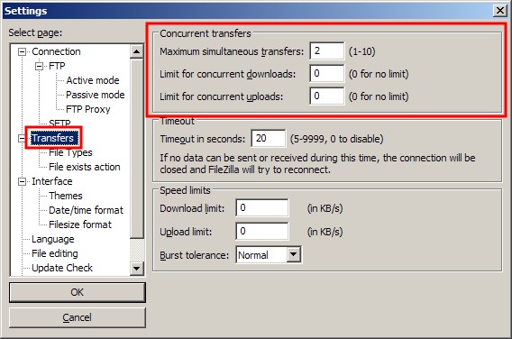
Those are the default settings.

Note that the FTP server administrator can limit the number of connections that you can make. If he limits you to one connection, then it doesn't matter how high you set the client. You'll be limited to one connection.

